

C:\Users\FSWCD_1\AppData\Local\Microsoft\Windows\Temporary Internet Files\Content.IE5\5PP8HDLP\MC900280296[1].wmf**Dairy Cows Lesson**

**Concept Objective:** Understand how cows are raised for

dairy, and how milk is turned into

dairy products.

**Time:** 40-45 minutes

**Setting:** Indoors

**Activities:** Read “Clarabelle: Making Milk and So Much More”, Make Butter, Make Farmer’s Cheese

**Procedure:**

1. Read “Clarabelle” to the students, then discuss the raising of dairy cows. Talk about the basics of animal care: food, proper shelter, lighting, heat, exercise, milking, and vet care.
2. Discuss Butter Making process with students, show pictures of Churns.
3. Eat the butter on crackers or bread.

**Making Butter**

MC900293562[1]Heavy Whipping Cream

Small Glass Jar with Lid

Salt

Crackers

1. Fill jar 2/3 full with heavy whipping cream.
2. Add small amount of salt if desired.
3. Have students shake vigorously for 1-2 minutes per students, then pass and continue shaking until distinct solids and whey forms.
4. Drain whey.
5. Serve on crackers or bread.

**Making Farmer’s Cheese**

Farmer cheese is an unaged (also known as fresh) mild white cheese with a crumbly texture. You don't need to be a farmer to make it yourself though; farmer cheese is really easy to make at home, and this simple recipe calls for just three ingredients. Once you make it, you'll start to see that it can be used in countless ways. Since this is a fresh cheese, you can easily add more flavor by customizing it with your favorite add-ins. For example, you can mix in fresh herbs with the curds or sprinkle them on top of the finished farmer cheese along with olive oil and red pepper flakes. Use farmer cheese as a spread, as you would cream cheese or goat cheese. Eat it like cottage cheese—just add berries. Add in honey and a little bit of jam or fresh fruit for a sweet twist and spread on crackers.

This fresh cheese is incredibly versatile. It can be eaten with bread or crackers or crumbled on top of salads. Try blending it with other cheeses such as ricotta, which is a similar but milder cheese, for lasagna, or combine it with yogurt, to make a savory dip or incorporate it into any recipe that calls for soft, fresh cheese.

Ingredients

Gallon of Milk

Thermometer

White Vinegar

Cheese Cloth

Butter

Salt

Herbs (optional)

Equipment Needed

Big enough pot to hold 1 gallon of milk

Thermometer

Deep Bowl

Dowel or large wooden spoon

Stirring and scooping spoons

Plastic container with lid

* Heat 1 gallon of milk to 206° (this recipe can be halved or doubled)
* Stir in ¼ cup of white vinegar (cider vinegar can be used but white vinegar gives a milder tasting result.) Add slightly more (1 Tbsp at a time) if curds don’t form.
* Stir gently and consistently for a couple minutes – you will see curds forming. Milk from late in the lactation period contains more milk solids and can make more cheese, but it needs more vinegar to separate out the curds. Add any additional vinegar 1 tablespoon at a time until the whey is a clear “green” color.
* Ladle set milk into colander. Tie the four corners of cheesecloth together, hang on the handle of a wooden spoon or dowel set over a deep bowl until it is the consistency of slightly dry cottage cheese, 1-2 hours. Transfer to a bowl and fold in salt and herbs if desired. Store in an airtight container, refrigerated for up to 1 week.
* Refrigerate until ready for use.

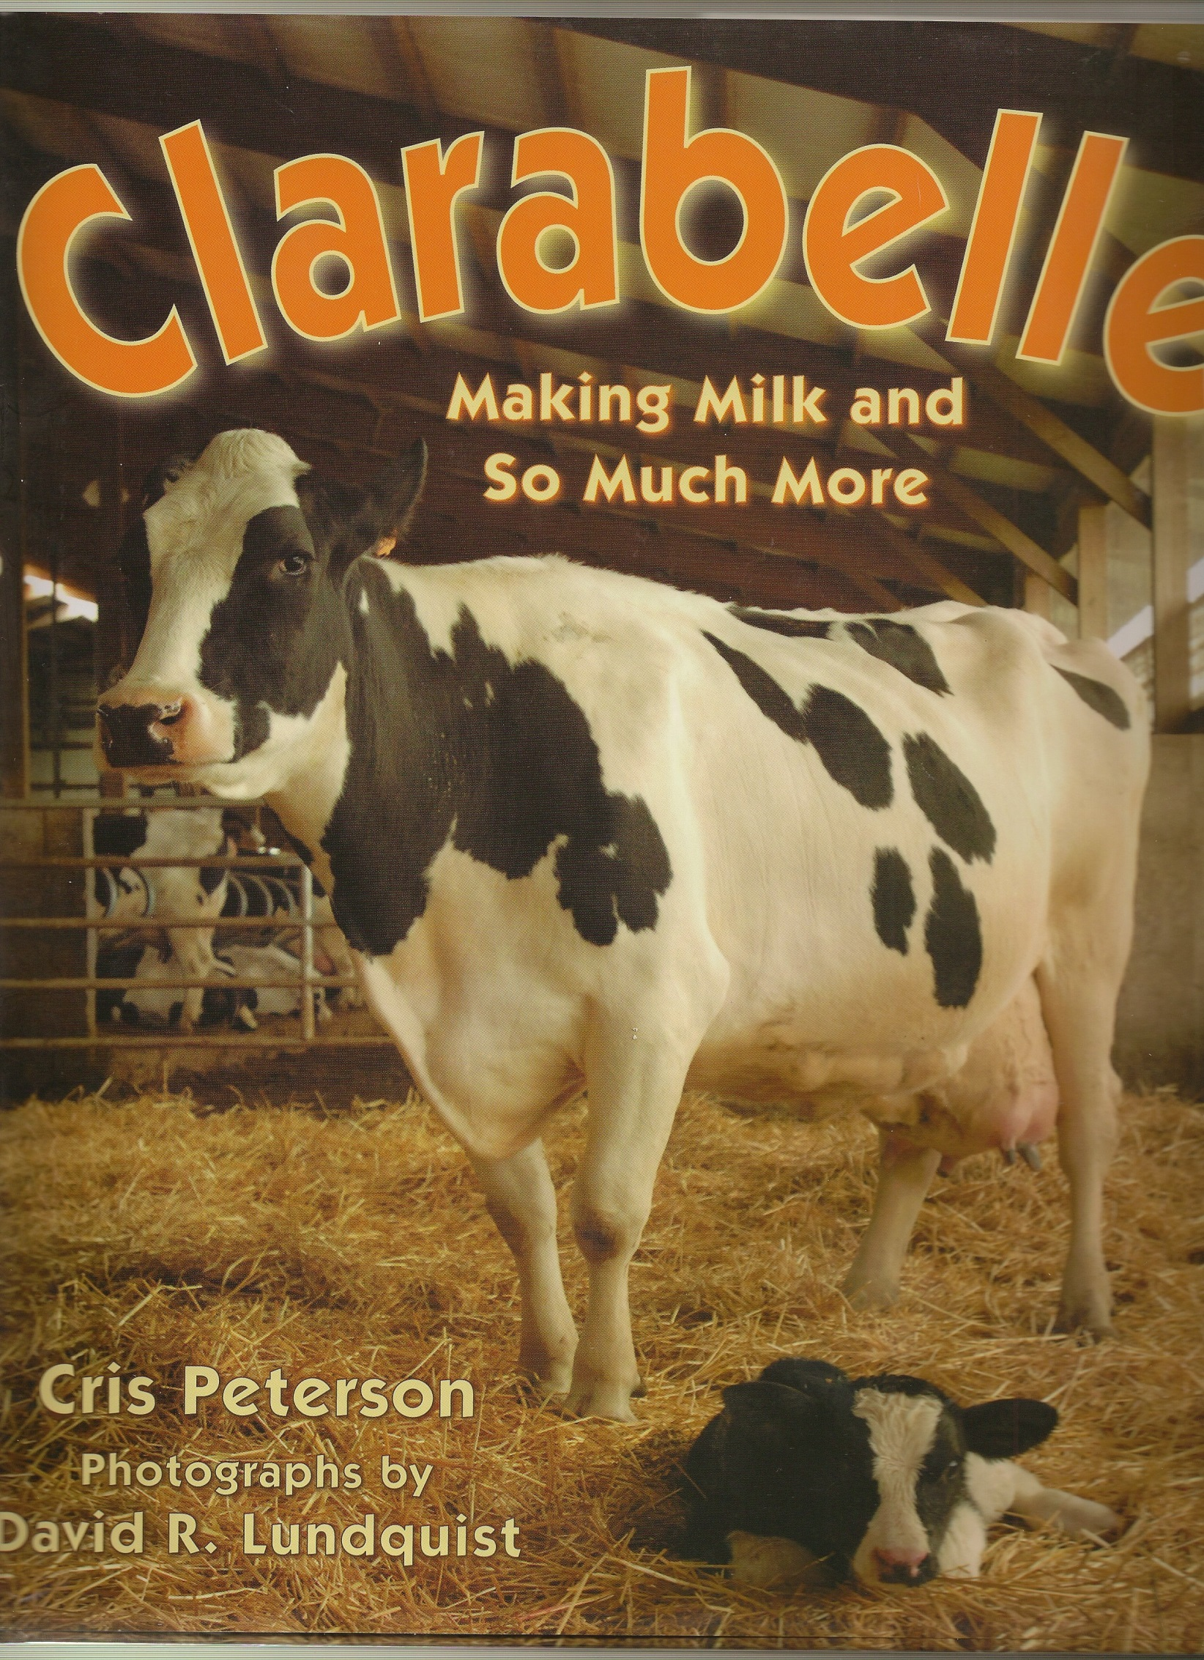

**Making Butter Background Information:**

# Butter-making - home churns and utensils

[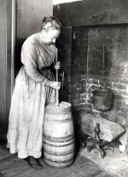](http://www.oldandinteresting.com/photocredit.aspx#Dairy)Home butter-making took time and energy, but only needed simple equipment. Low-tech methods were still well-known in rural parts of developed countries like the USA in the mid-20th century. In the UK it became less common for ordinary families to make their own butter in the course of the 19th century, but the old ways were still used on small farms and in the dairies belonging to grand houses.

After the cow(s) were milked, the milk was left to settle in a cool place, in shallow dishes, also called setting dishes or pancheons, so the cream would rise to the top. (Unless the butter was to be made from whole milk: less common than making it from cream.) Brass and earthenware dishes were used in the UK in the 17th and 18th centuries, with earthenware becoming gradually more popular, as brass sometimes tainted the flavor.

After half a day or so, the cream was skimmed off and put ready for the churn. Small home producers would want to collect a few days of milking to have enough cream to be worth churning, and a little fermentation would "ripen" the flavor. But the cream couldn't be left waiting too long in summer-time.

Cream-skimmers were used to lift off the cream. These worked well if they were shallow with a thin, almost sharp, edge. Skimmers from the last couple of centuries were often saucer-shaped with perforations to catch the cream while letting milk drip back into the pan, just like those used to remove surface "scum" from stock. Brass cream-skimmers on long or short handles are decorative antiques now, but some were much simpler. Anything the right shape would serve the purpose, like this wooden skimmer made to an older design. Other names for these were fleeter, scummer, skimming spoon, skimming ladle.

## Churning

Moving the cream constantly is the churning that actually produces butter by separating out the yellow fat from the buttermilk. Simply shaking it in a closed jam jar for an hour or so will work, or you can swing unseparated milk in an animal skin hung on sticks, an ancient method still used in some parts of the world.

### Plunge churn or dash churn

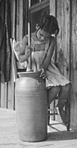A stick called a dasher or churn dash was moved up and down by hand in an upright container, usually made of wood or earthenware, as in the first two pictures on this page. A churn lid from 1400 years ago, with a hole for the stick, shows that this method has a long history. The stick might be perforated, or it could have a wooden circle, or crossed boards attached, but even with those to help beat the cream, this method took longer than using the more complex kinds of churn which were introduced in the 18th century, and became popular in the 19th.

# Churning Song

*Churn butter churn*

*Churn butter churn*

*“Peter” is standing at the gate*

*Waiting for a buttered cake*

(substitute next person to “churn” butter for Peter’s name as you pass the jar around to take turns.)

The long job had its own rhyme (see above). This was sometimes thought of as a charm to make the cream turn into butter, and sometimes as a song which went with the rhythm of the work. It was widely known on both sides of the Atlantic, with many variations, and was probably already old when mentioned in print in 1685. Many cultures had their own churning songs. Some had other charms and superstitions too. Both in Europe and North America metal objects - like needles, knives or horseshoes - were used to drive away evil influences which might prevent cream from turning to butter.

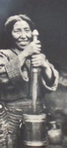Other names for this long-established kind of churn are 'up and down' churn, churning tub, plunger churn, plumping churn, knocker churn, plump-kirn, or plowt-kirn. (Kirn is a Scots and Northern English word for churn.) Other names for the dash are dasher-staff, churn-staff, churning-stick, plunger, plumper, or kirn-staff.

Churns based on a pot and stick are used in Asia too. Indian churns are often operated by ropes and pulleys, handled by one or two people. Tibetan yak butter is also made with a dasher in a container, as pictured right.

### Paddle churn

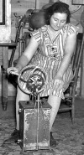A wooden box or earthenware crock had a paddle inside attached to a rod, which was turned by a handle on the top or side. These contraptions, which could also be metal, were widely sold as small, convenient household churns in 19th century America, like the wooden one in the photo (right), or this early 20th century [glass one](http://en.wikipedia.org/wiki/Image:Butter1web.jpg) in use in the US in the 1940s. This sort of churn was also used for domestic butter-making in New Zealand.

### Barrel churn

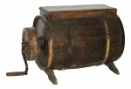The whole churn might be turned round by a handle, or the handle would operate a crank turning paddles inside the barrel. Some were squarer looking and called box churns. The French call the kind in the photograph a Norman churn. There were also barrel- and box-shaped churns which swung or rocked instead of turning. More elaborate barrel churns were probably for larger-scale farm production and don't

really count as household items.

**Shaping & Keeping**

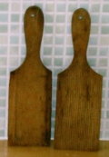After the cream had formed lumps of butter, it still wasn't ready for serving or preserving. It was taken out of the churn, probably with wooden scoops, ready to be refined, salted and shaped.

**Removing buttermilk, adding salt**

All the buttermilk separated from the butterfat had to be rinsed out. This would improve texture and flavor, and also help the butter keep well, since milk turns rancid more quickly than fat alone. Salt was usually mixed in at this stage - for flavor and preservation.

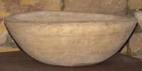

The rinsing could be done simply by washing in water, followed by draining, salting and working or "kneading" the butter with a pair of wooden butter hands, (see right), or with bare hands.

Until the 19th century working the butter with your hands was the norm. The wooden bowl (left) was used by Yorkshire butter-makers to hold the butter while they "clashed" it - prepared it by hand. In the 19th century the butter worker - a wooden tray with roller - was invented to help with these processes. In Wales butter working was done with a circular wooden tool in a round bowl like an open shallow barrel.

**Butter hands, butter molds**

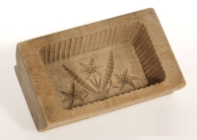The wooden spatulas/paddles (above) used for manipulating the butter have several different names - Scotch hands, butter pats, butter paddles, beaters, clappers, spades among others. They can be put to use in various ways. As well as doubling up as scoops for taking butter from the churn, they can stir, cut, slap, lift. They can cut and shape the butter into a block, and then mark its top with a local design of crosses or grooves. Or they may be used to press butter into a mold. (See right)

In grocers' shops in Britain the "hands" were used well into the 20th century to cut a piece of butter from a large block, on request from a customer. In the kitchen they were used to make individual butter balls for serving at table - just roll a small lump around between the two wooden pats.

**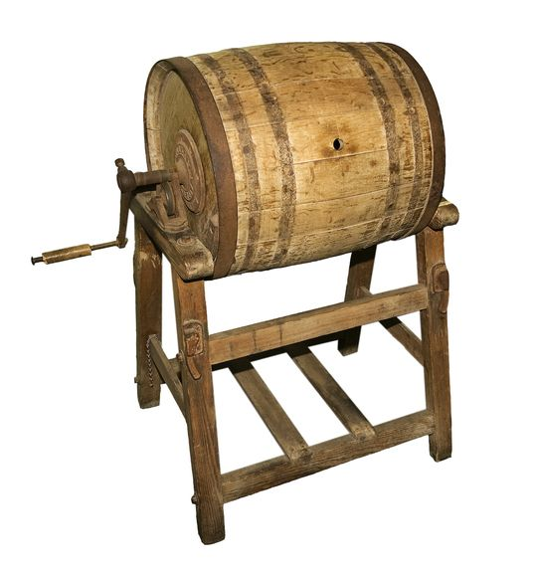**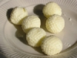In England butter might be formed into various shapes. This 18th century was designed to keep a rounded top on a lump of butter. During the 19th century half-pound bricks became a standard shape, even though bulk buyers bought barrels or large blocks. Patterns, stamped or cut, might mark the original source. The patterns varied by region - with cross designs associated with the north-west and thistles with Yorkshire. In the US both pounds and half-pounds of butter were common, sometimes wrapped in good quality dairy cloths, not just in thin butter muslin/cheesecloth.

**